Indian Institute of Technology,Guwahati



Depratment Of Mechanical Engineering

Computational Fluid Dynamics
(ME543)

Home Assignment 1

Submitted To:
Prof. Anoop K.Das

Submitted By:
Mritunjay
Roll No. 214103004

Table of Content

1. C codes
- Gauss Seidal
- Time Marching Method
- PSOR Method
- PSOR with Different over Relaxation factor
- Analytical Method

2. Table 1- for Results
3. Graph between No. Of Iterations V/s Different Over Relaxation factor
4.Tempurature Contour

1. C codes

Problem 1. Gauss Seidal Mthod:

#include<stdio.h>
#include<math.h>
#include<stdlib.h>
void main()
{
double u[40][20],error=0,store[40][20];
int i,j;

for(i=0;i<21;i++)
{
u[0][i]=100;
store[0][i]=100;
}

for(j=1;j<41;j++)
{
for(i=0;i<21;i++)
{
u[j][i]=0;
store[j][i]=0;

}
}
do
{
error=0;
for(j=1;j<40;j++)
{

for(i=1;i<20;i++)
{
u[j][i]=(u[j+1][i]+u[j-1][i]+u[j][i+1]+u[j][i-1])*0.25;
error=error+fabs(u[j][i]-store[j][i]);
store[j][i]=u[j][i];
}
}
}while(error>.01);
printf("\nthe error is =%f",error);
printf("\n the solutions are\n");
for(j=0;j<41;j++)
{
for(i=0;i<21;i++)
{
printf("%d\t%d\t%f\n",j+1,i+1,u[j][i]);
}
printf("\n");
}
}

Problem 2. Time marching method:

#include<stdio.h>
#include<math.h>
#include<stdlib.h>
void main()
{
double u[40][20],error=0,store[40][20];
int i,j;

for(i=0;i<21;i++)
{
u[0][i]=100;
store[0][i]=100;
}

for(j=1;j<41;j++)
{
for(i=0;i<21;i++)
{
u[j][i]=0;
store[j][i]=0;

}
}
do
{
error=0;
for(j=1;j<40;j++)
{

for(i=1;i<20;i++)
{
u[j][i]=(u[j+1][i]+u[j-1][i]+u[j][i+1]+u[j][i-1])*0.25;
error=error+fabs(u[j][i]-store[j][i]);
store[j][i]=u[j][i];
}
}
}while(error>.01);
printf("\nthe error is =%f",error);
printf("\n the solutions are\n");
for(j=0;j<41;j++)
{
for(i=0;i<21;i++)
{
printf("%d\t%d\t%f\n",j+1,i+1,u[j][i]);
}
printf("\n");
}
}

Problem 3. PSOR Method:

#include<stdio.h>
#include<math.h>
#include<stdlib.h>
#define pi 3.1428
void main()
{
double u[40][20],error=0,store[40][20];
int i,j;
float a,w;
a=pow((cos(pi/20)+cos(pi/40))/2,2);
w=(2-2*sqrt(1-a))/a;
printf("a=%f\n",a);
printf("w=%f\n",w);

for(i=0;i<21;i++)
{
u[0][i]=100;
store[0][i]=100;
}

for(j=1;j<41;j++)
{
for(i=0;i<21;i++)
{
u[j][i]=0;
store[j][i]=0;

}
}
do
{
error=0;
for(j=1;j<40;j++)
{

for(i=1;i<20;i++)
{
u[j][i]=(1-w)*u[j][i]+w*((u[j+1][i]+u[j-1][i]+u[j][i+1]+u[j][i-1])/4);
error=error+fabs(u[j][i]-store[j][i]);
store[j][i]=u[j][i];
}
}
}while(error>.01);
printf("\nthe error is =%f",error);
printf("\n the solutions are\n");
for(j=0;j<41;j++)
{
for(i=0;i<21;i++)
{
printf("%d\t%d\t%f\n",j+1,i+1,u[j][i]);
}
printf("\n");
}
}

Problem 4. PSOR with Different Over Relaxation Factor:

#include<stdio.h>
#include<math.h>
#include<stdlib.h>
#define pi 3.1428
void main()
{
FILE *out;
out=fopen("gauss1.dat","w");
fprintf(out,"#It\tRelaxation factor\n");

double u[40][20],error=0,store[40][20];
int i,j,count=1;
float a,w;
for(w=0.8;w<=2.0;w=w+0.1)
{
count=1;
for(i=0;i<21;i++)
{
u[0][i]=100;
store[0][i]=100;
}

for(j=1;j<41;j++)
{
for(i=0;i<21;i++)
{
u[j][i]=0;
store[j][i]=0;

}
}
do
{
error=0;
for(j=1;j<40;j++)
{

for(i=1;i<20;i++)
{
u[j][i]=(1-w)*u[j][i]+w*((u[j+1][i]+u[j-1][i]+u[j][i+1]+u[j][i-1])/4);
error=error+fabs(u[j][i]-store[j][i]);
store[j][i]=u[j][i];
//fprintf(out,"%d\t%f\n",count,w);
}
}
count++;

}while(error>.01);
printf("%d\t%f\n",count,w);
fprintf(out,"%d\t%f\n",count,w);

}
printf("\n");
/*printf("\nthe error is =%f",error);
printf("\n the solutions are\n");
for(j=0;j<41;j++)
{
for(i=0;i<21;i++)
{
//printf("%d\t%d\t%f\n",j+1,i+1,u[j][i]);
}
//printf("\n");
}*/
}

Problem 5. Analytical Method:

#include<stdio.h>
#include<math.h>
int main()
{

float pi=3.1416,X,Y,sum;
float T[41][21];
int n,i,j;
for(i=0;i<41;i++)
{
for(j=0;j<21;j++)
{
if(i==0)
T[i][j]=100;
else
T[i][j]=0;
}
}

for(i=1;i<40;i++)
{
for(j=1;j<20;j++)
{
X=i*0.05;
Y=j*0.05;
sum=0;
for(n=1;n<=110;n++)
{
sum=sum+((1-(pow(-1,n)))/(n*pi))*sinh((n*pi*(2-X))/1)*sin(n*pi*Y/1)/sinh(n*pi*2/1);
}
T[i][j]=100*2*sum;
}
}
for(i=2;i<41;i++)
{
for(j=2;j<21;j++)
{
printf("T[%d][%d]=%f\t",i,j,T[i][j]);
printf("\n");
}

}
}

2.Table of Result

i | J | Gauss Seidal | Time Marching | PSOR | Analytical  Method
11 | 1 | 0 | 0 | 0 | 0
11 | 2 | 4.34 | 4.34 | 4.35 | 4.32
11 | 3 | 8.53 | 8.53 | 8.54 | 8.51
11 | 4 | 12.44 | 12.44 | 12.44 | 12.41
11 | 5 | 15.94 | 15.94 | 15.95 | 15.92
11 | 6 | 19.01 | 19.01 | 19.01 | 18.96
11 | 7 | 21.55 | 21.55 | 21.54 | 21.52
11 | 8 | 23.55 | 23.55 | 23.55 | 23.51
11 | 9 | 24.96 | 24.96 | 24.97 | 24.94
11 | 10 | 25.82 | 25.82 | 25.82 | 25.79
11 | 11 | 26.11 | 26.11 | 26.13 | 26.08
11 | 12 | 25.82 | 25.82 | 25.83 | 25.79
11 | 13 | 24.96 | 24.96 | 24.96 | 24.94
11 | 14 | 23.53 | 23.53 | 23.54 | 23.50
11 | 15 | 21.55 | 21.55 | 21.56 | 21.55
11 | 16 | 19.03 | 19.03 | 19.04 | 19.01
11 | 17 | 15.96 | 15.96 | 15.94 | 15.92
11 | 18 | 12.44 | 12.44 | 12.45 | 12.42
11 | 19 | 8.53 | 8.53 | 8.53 | 8.51
11 | 20 | 4.33 | 4.33 | 4.32 | 4.31

3. Graph between No. Of Iterations V/s Different Over Relaxation factor:
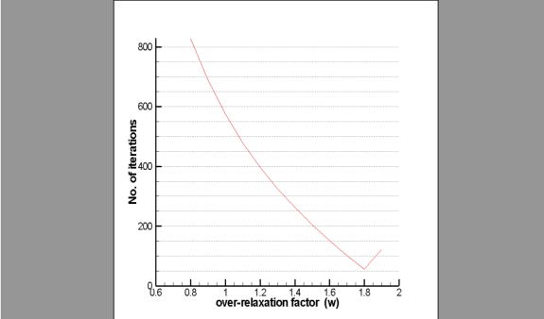
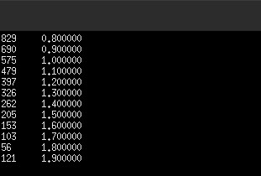

Conclusion:From the above graph we can conclude that as the Over-relaxation factor Increases upto a certain limit No. Iterations decreases as it reaches its optimum value it again stars increasing.

4.Temperature Contour

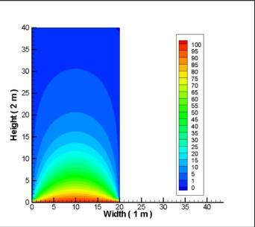
Conclusion: The Temperature distribution can be seen on above tecplot.

